LAB # 08


Introduction to HTML (Continued)

Fall 2022
CSE101L Computer Fundamentals Lab

Submitted by: Haris Khan
Registration No. : 60032
Class Section: A

“On my honor, as student of University of Engineering and Technology, I have neither given nor received unauthorized assistance on this academic work.”

Student Signature: ______________

Submitted to:
Engr. Abdullah Hamid
January 02, 2023

Department of Computer Systems Engineering
University of Engineering and Technology, Peshawar

Step #01:
In the first step, I coded an html program in brackets.
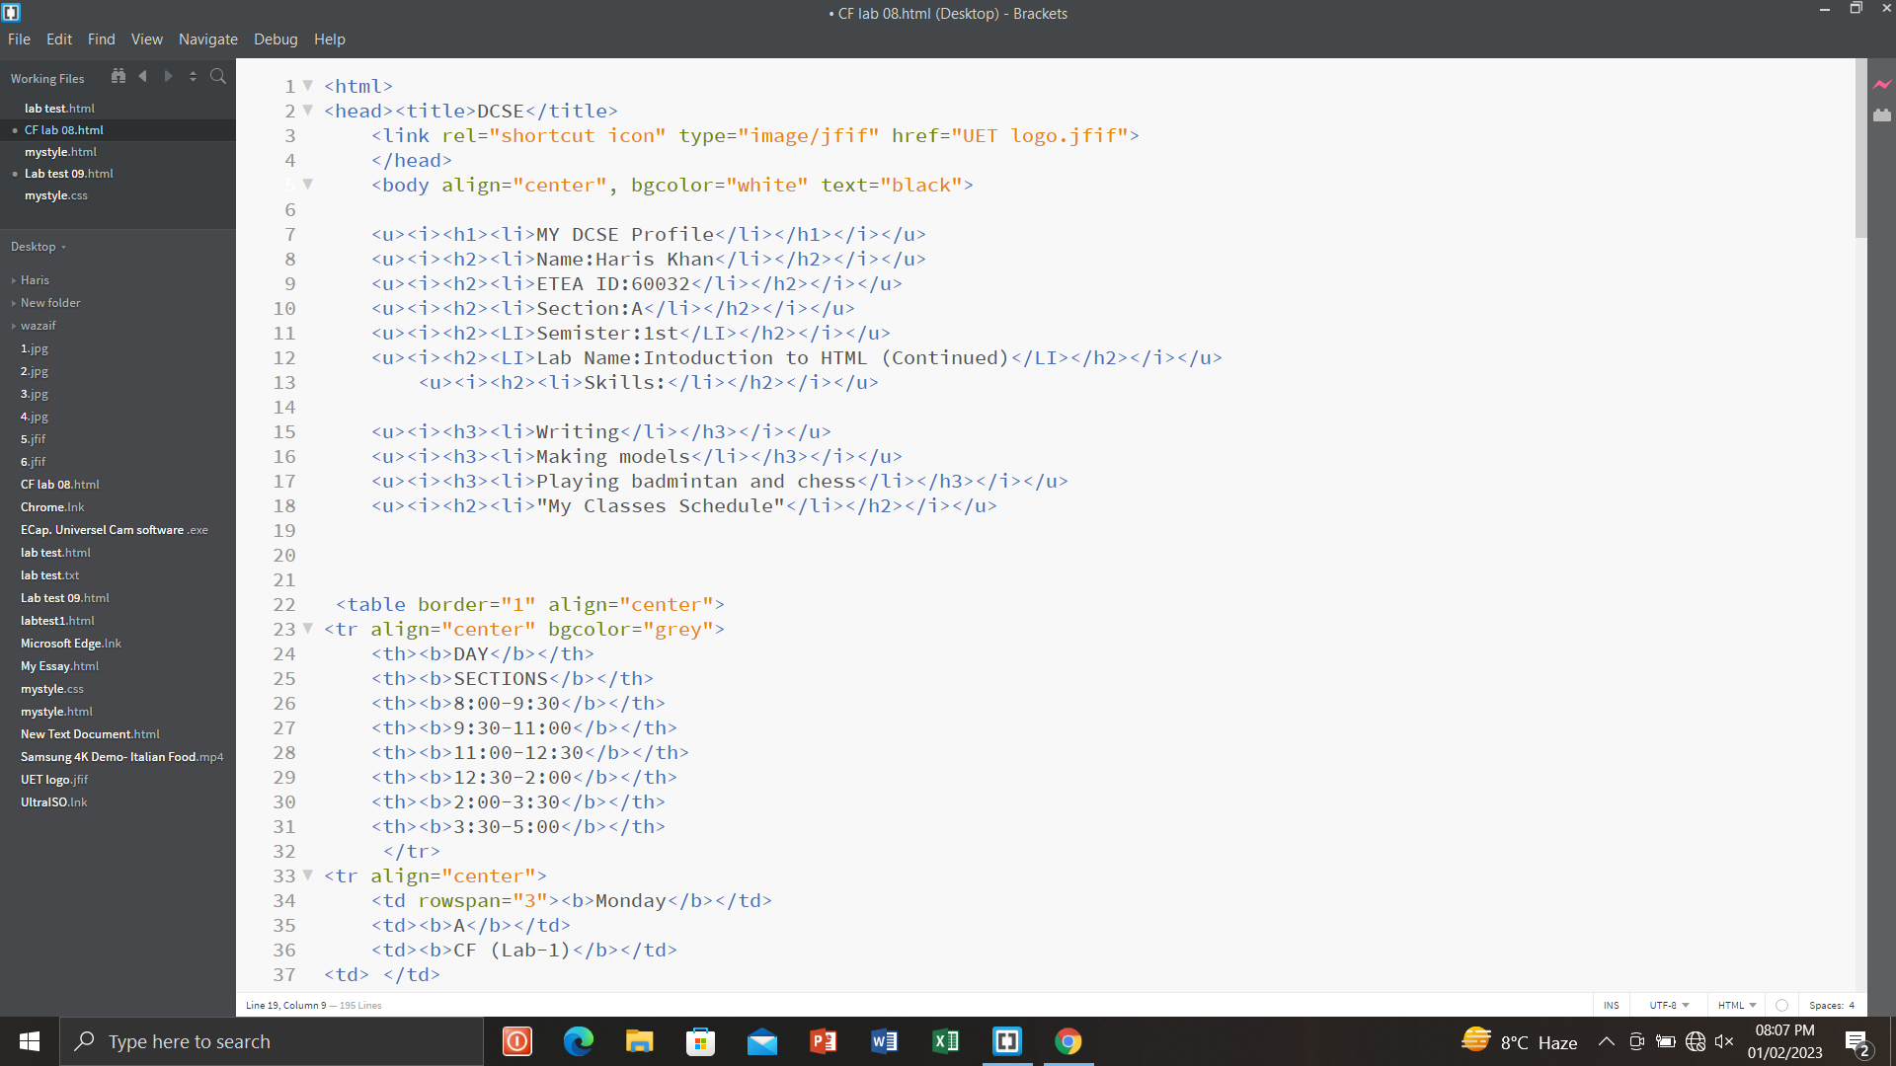
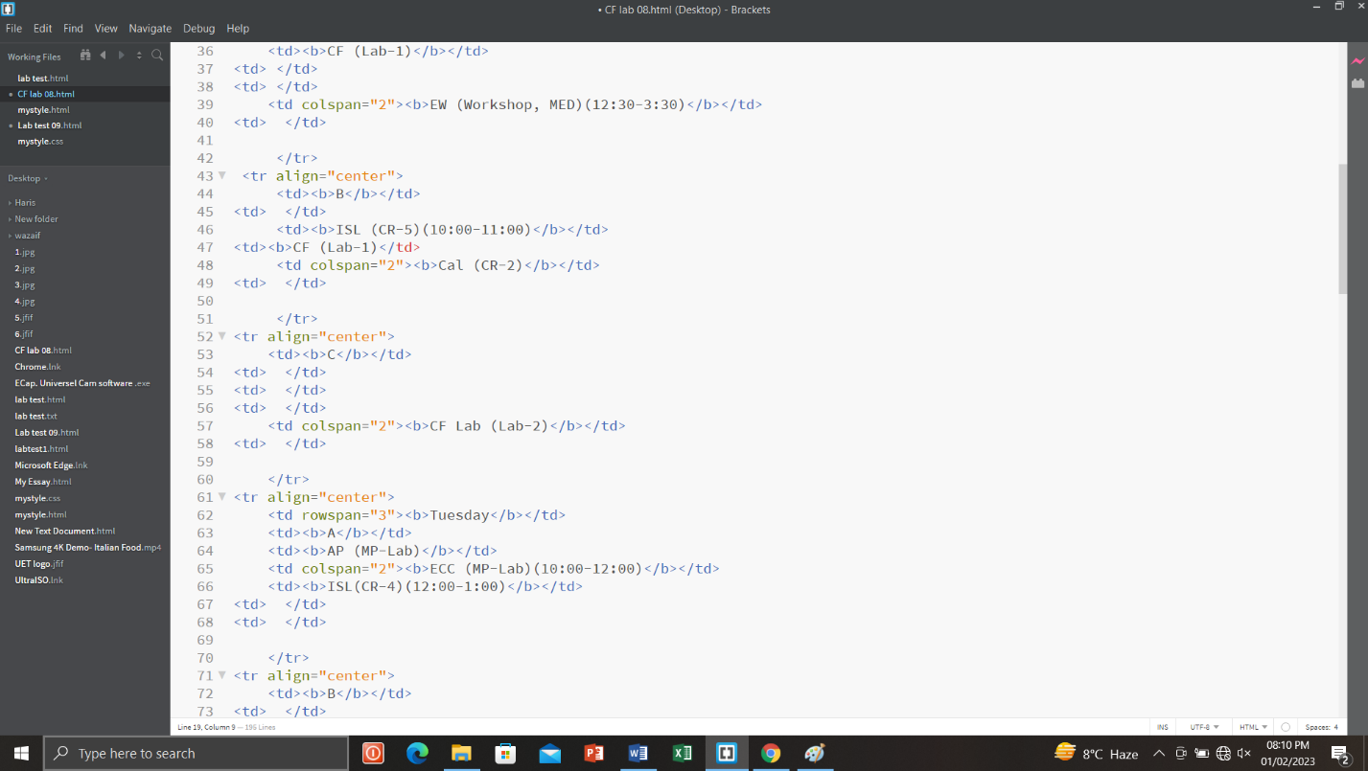

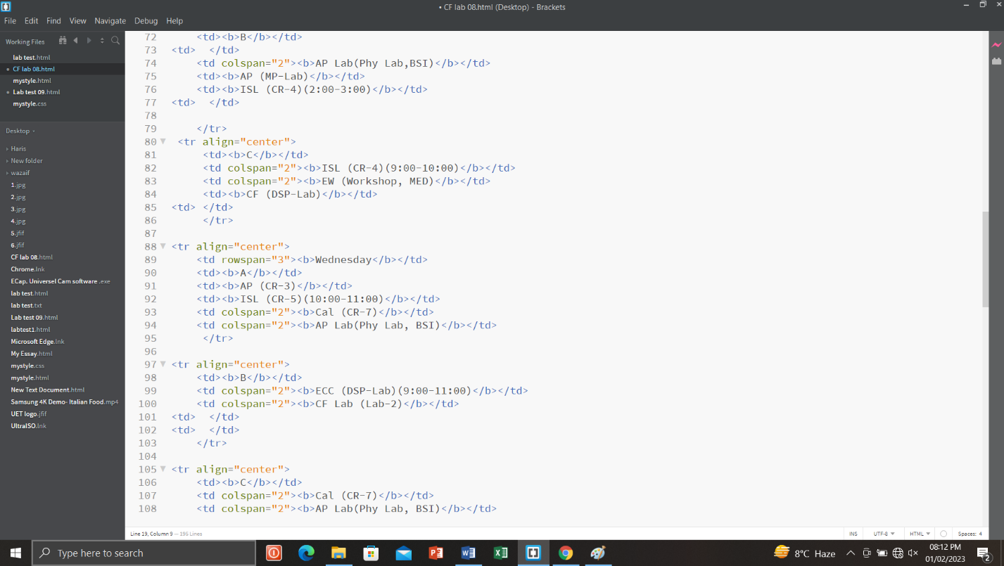

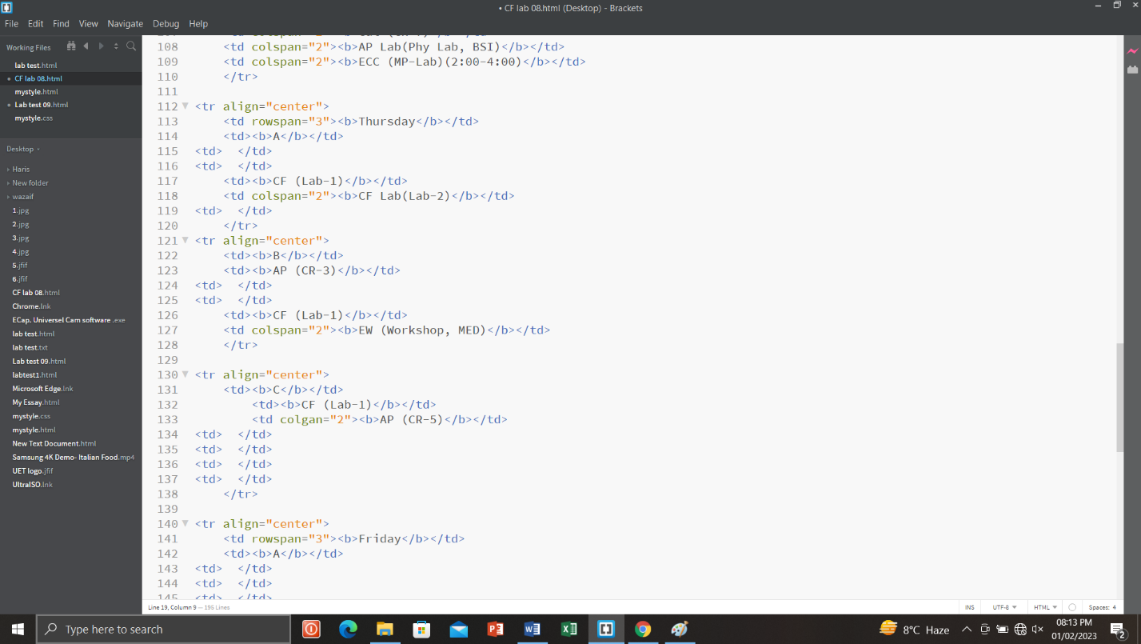

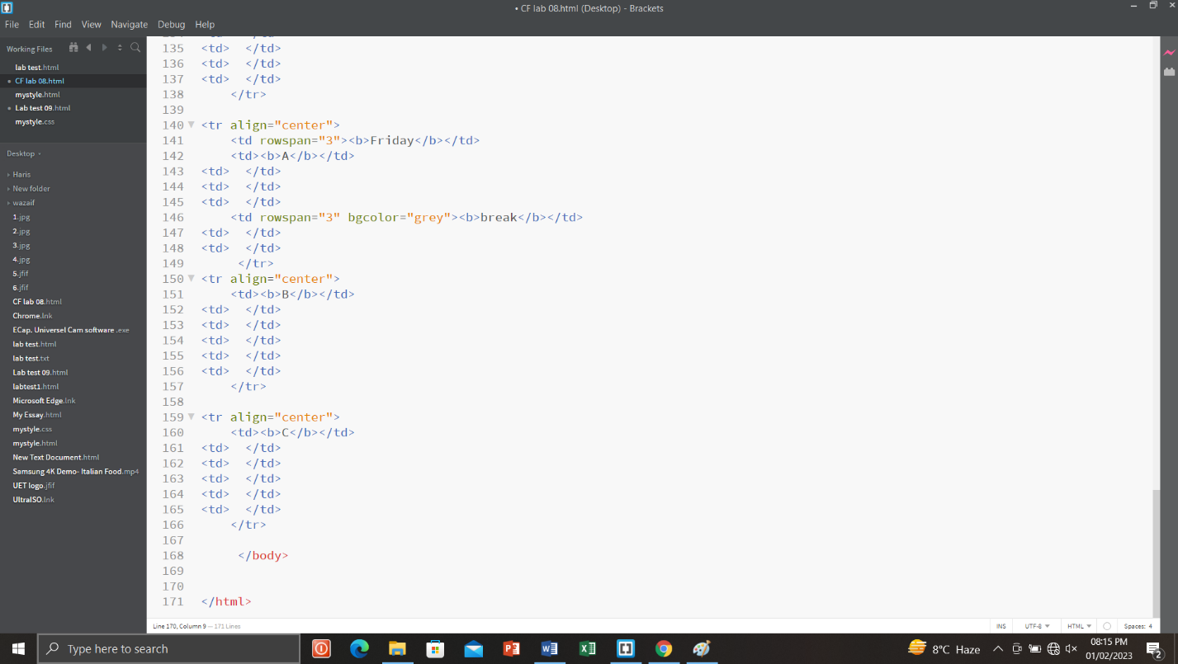

Step #02:
In the second step, I run the program coded in html.
